Professional English to use, p. 47

№1

1. network analyst
2. systems analyst
3. software engineer
4. hardware engineer
5. database administrator
6. network administrator
7. trainer
8. help desk technician

№2

1. A **technical writer** writes documentation of a program or device
2. A **project manager** controls all the operations and people in a project
3. A **web designer** plans and keeps websites updated
4. A **security specialist** designs applications against viruses

№3

1. Computer operator
2. Database manager

№4

1. teleworker
2. a desktop publisher
3. telemedicine
4. online teacher
5. ICT?
6. computer animators

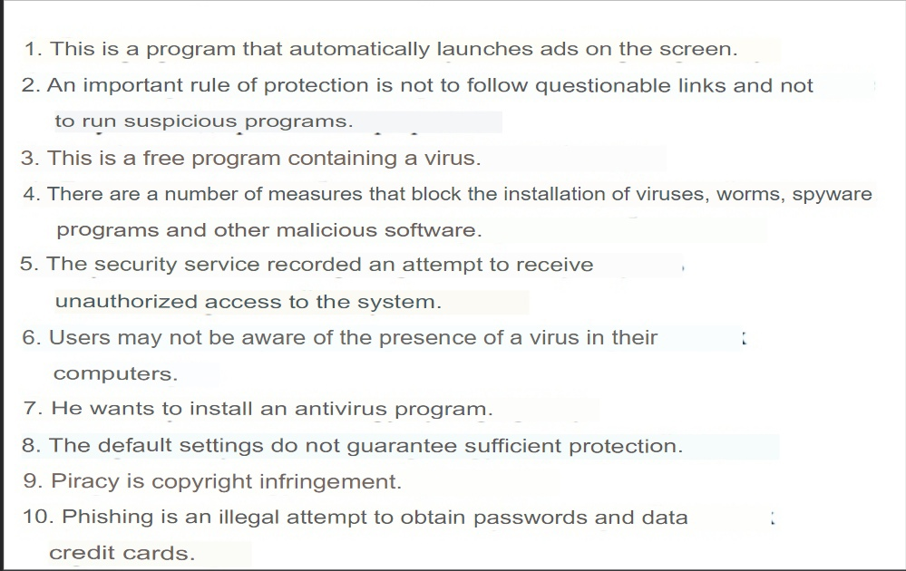

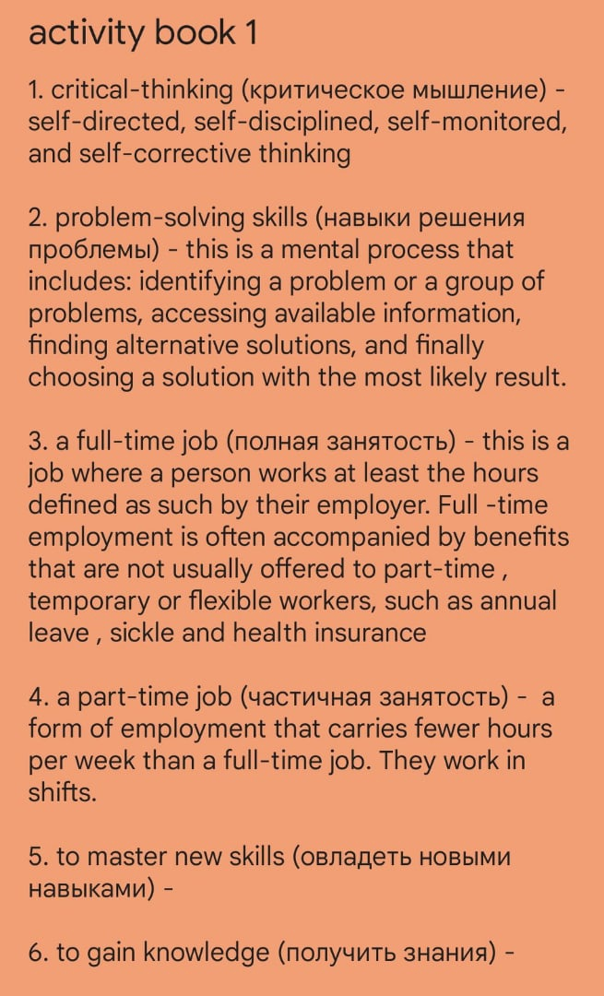

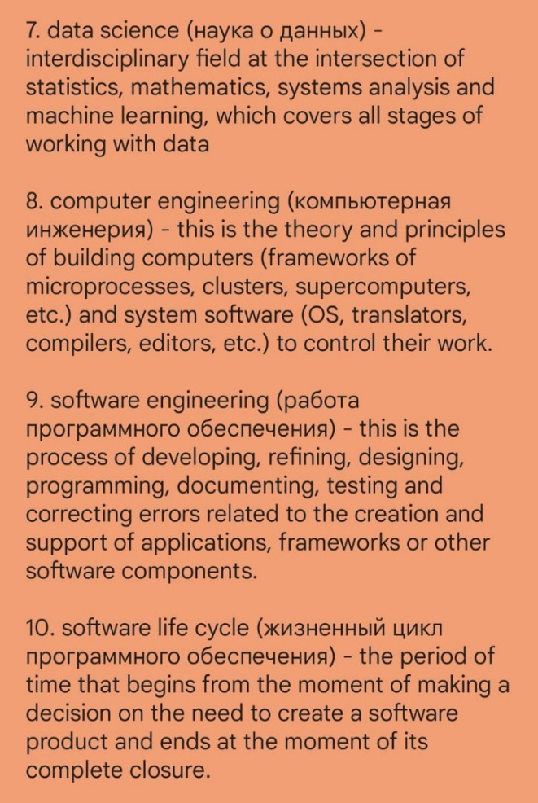

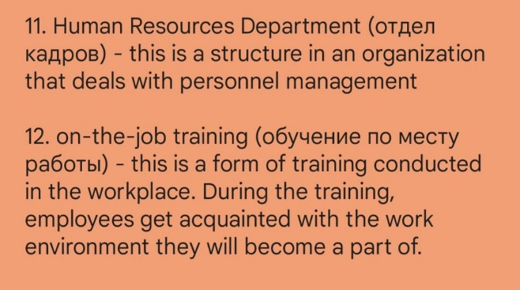

Activity book Unit 10(2)

1. How does the software life cycle affect jobs in the software industry?

The software life cycle is accelerating, which means that companies must develop technology is getting faster and faster. To do this, the company needs to hire more and more qualified employees.

1. What are the advantages of joining IEEE and ACM?

Membership in these professional organizations provides opportunities for networking and further career advancement.

Activity book Unit 10 (3)

1 - g,

2 - a,

3 - f,

4 - b,

5 - d,

6 - c,

7 – e

Activity book Unit 10 (4)

**1. a long-term goal -** These are big goals that take time to achieve.

**2. become familiar with something** - Get information, acquire some knowledge, get an idea about something.

**3. an exponential rise -** an increase in a quantity when the growth rate is proportional to the value of the quantity itself

**4. opportunities for networking -** gaining useful contacts in any field

**5. high-tech economy -** type of economy based on the flow of innovation, on constant technological improvement, on the production and export of high-tech products with very high value added and technologies themselves.